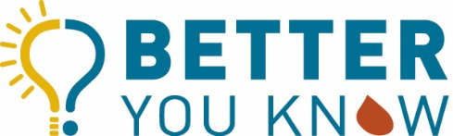

[Insert Logo/put on letterhead]

[Insert Date]

Dear [Insert Partner Name],

Up to 1% of women in the United States are estimated to have a bleeding disorder, and many don’t know it. That may not sound like a large percentage but it is the more than the entire population of Chicago! Yet, most people haven’t heard of bleeding disorders, despite the fact that they have a large impact on the lives of people living with them, especially women. Bleeding disorders, like hemophilia and von Willebrand Disease, are inheritable disorders where specific proteins in the blood are missing or don’t work properly, making it hard for the blood to clot.

Women with bleeding disorders very often have heavy menstrual bleeding, and by heavy we mean heavy…changing their tampon or pad at least every hour and having periods that last longer than 7 days. In fact, I was just chatting with a woman at a local education day who shared that her period typically lasts for three weeks! Bleeding disorders in women can be hard to identify and diagnose, sometimes even leading to drastic procedures, like hysterectomies, that possibly could have been avoided with proper diagnosis and treatment.

All of this is why I am writing you today. [Insert your organization or name], is excited to share with you a new campaign, our Better You Know campaign, to raise awareness of bleeding disorders in women and to drive women to betteryouknow.org where they can enter in their symptoms to find out if they are at risk for a bleeding disorder. We really want to reach women where they are at, and know that [Insert Partner Name] is doing amazing work reaching women. This is a great fit with Better You Know, and we would love to talk with you more about how we can possibly work together to impact women’s health and make their periods a more positive experience.

For more information, visit https://betteryouknow.org, which includes 9 short videos of women sharing their experiences with a bleeding disorder, as well as the print materials we have created for the campaign. We would love to chat with you more about how to potential put the word out through [Insert Partner Name],or your blog, or even to get women with bleeding disorders to learn more about [Insert Partner Name], to help with their long cycles.

Sincerely,

[Insert Your Name and Organization],

